| Course Name | ITD 2343 – Object Oriented Programming with C# |
| --- | --- |
| Instructor | Mark L. Pranger |
| Student Name | <Ezequiel Barrientos> |
| Due date | <10/7/25> |
| Grade | <grade earned here> |
| Grading Comments | <instructor comments here> |

Test Scenerio 1: Left -1000, Right 1000, Check number 501

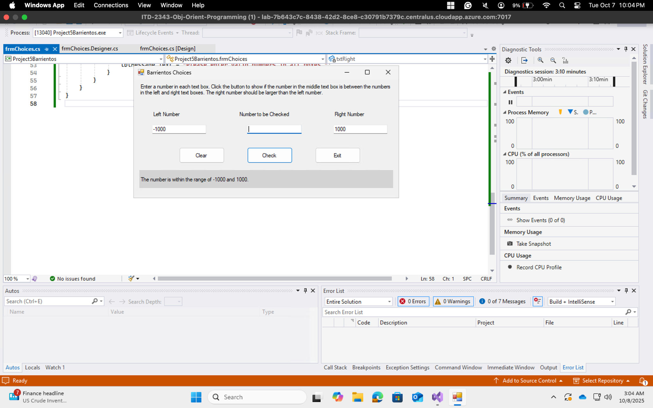

Test Scenario 2: Left -1000, Right 1000, Check -1000

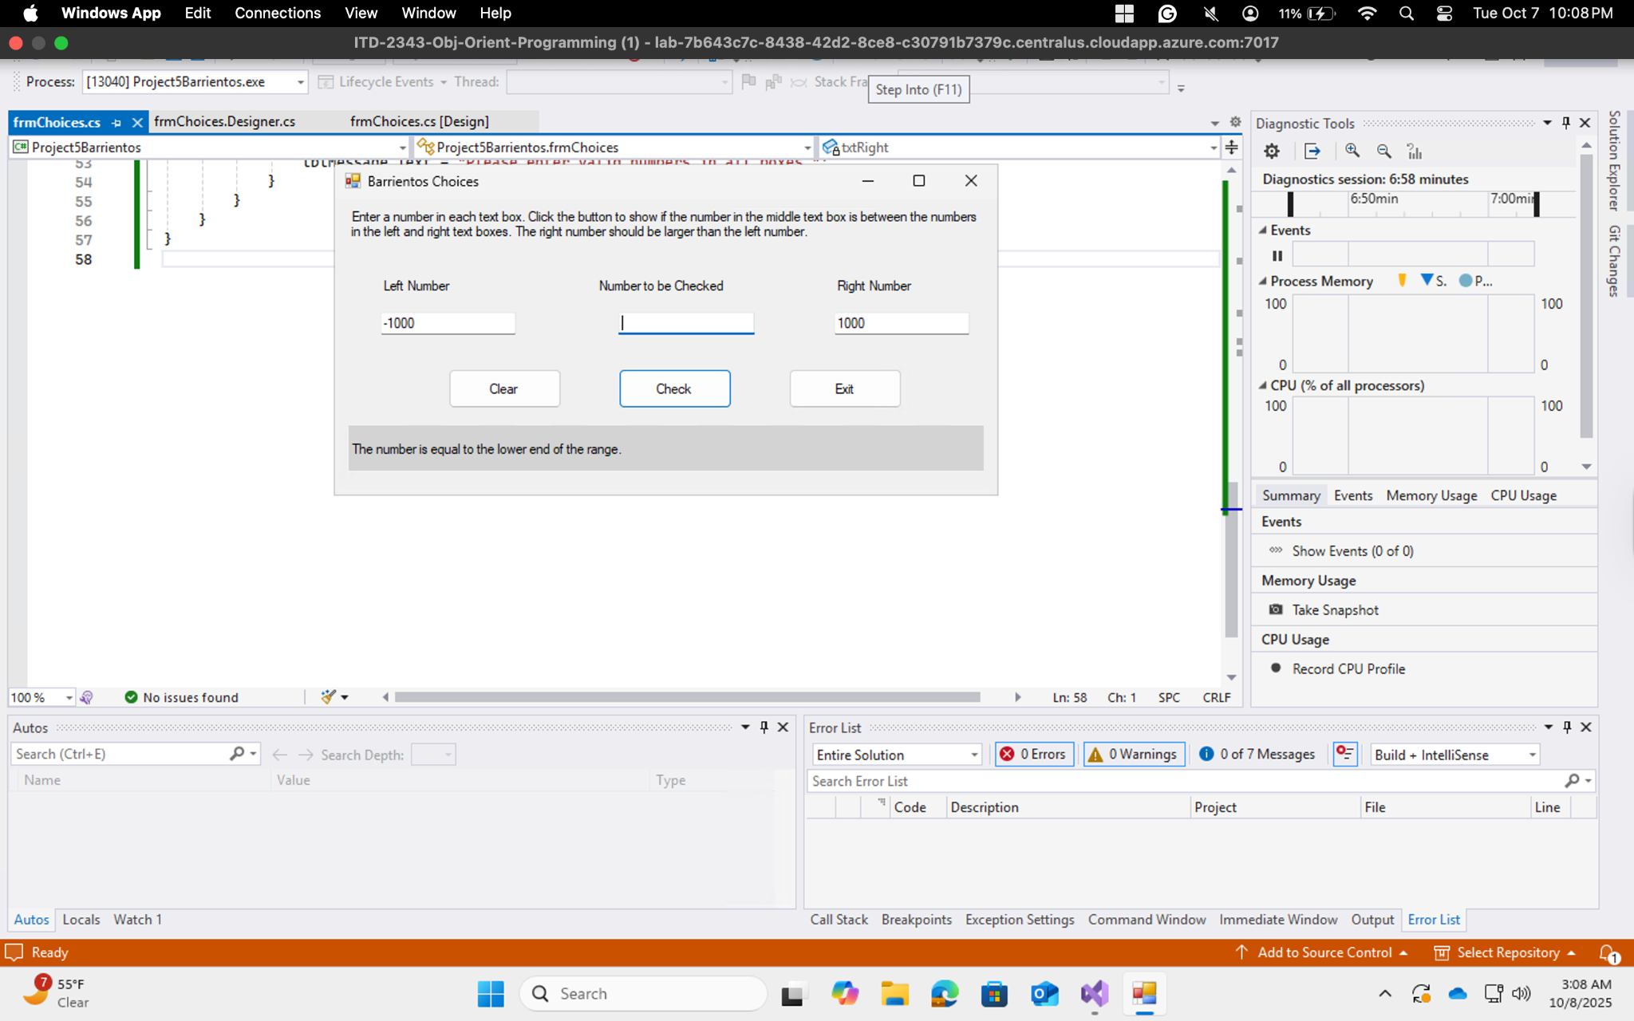

Test Scenario 3: Left -1000, Right 1000, Check 1000

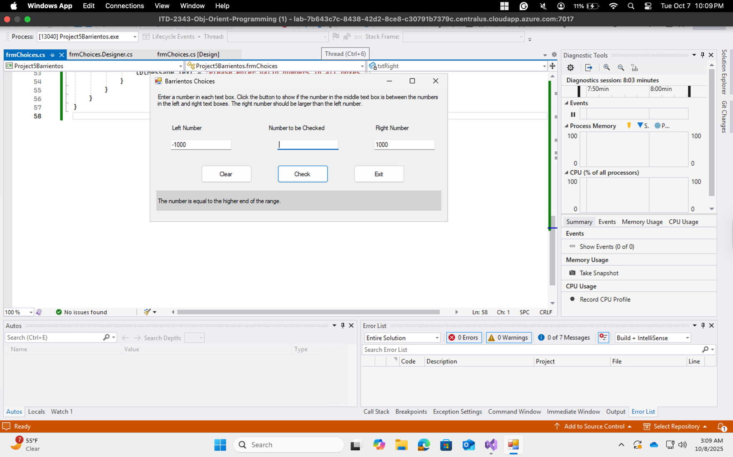

Test Scenario 4: Left -1000, Right 1000, Check 2021

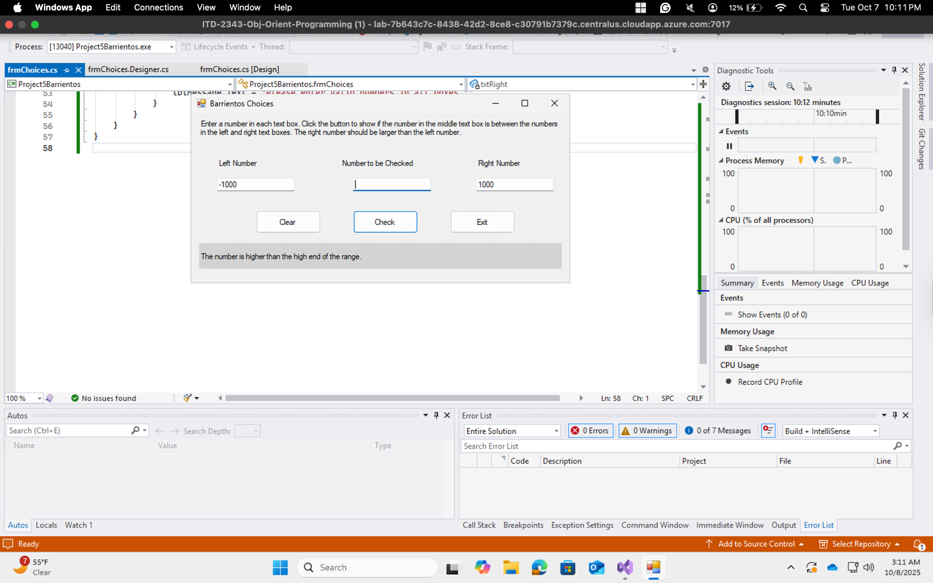

Test Scenario 5: Left -1000, Right 1000, Checked -2021

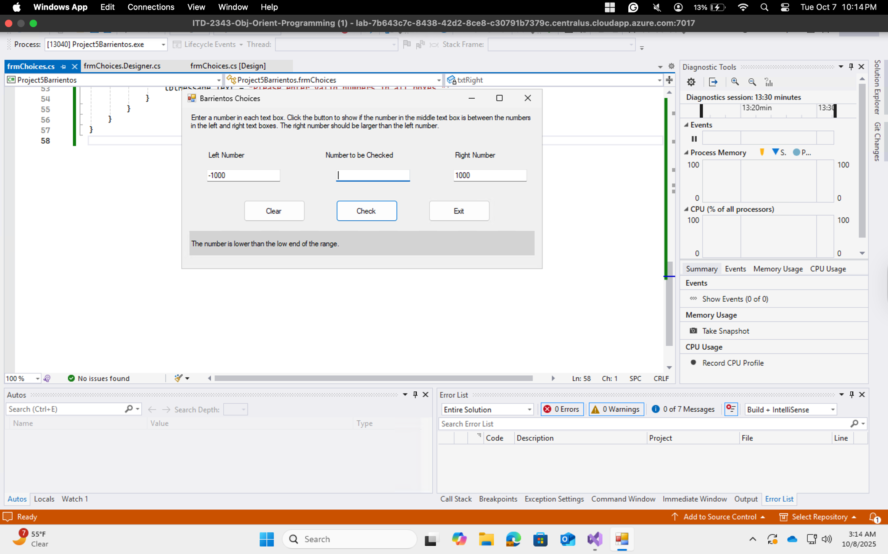

Test Scanerio 6: Left 500, Right 500, Checked 500

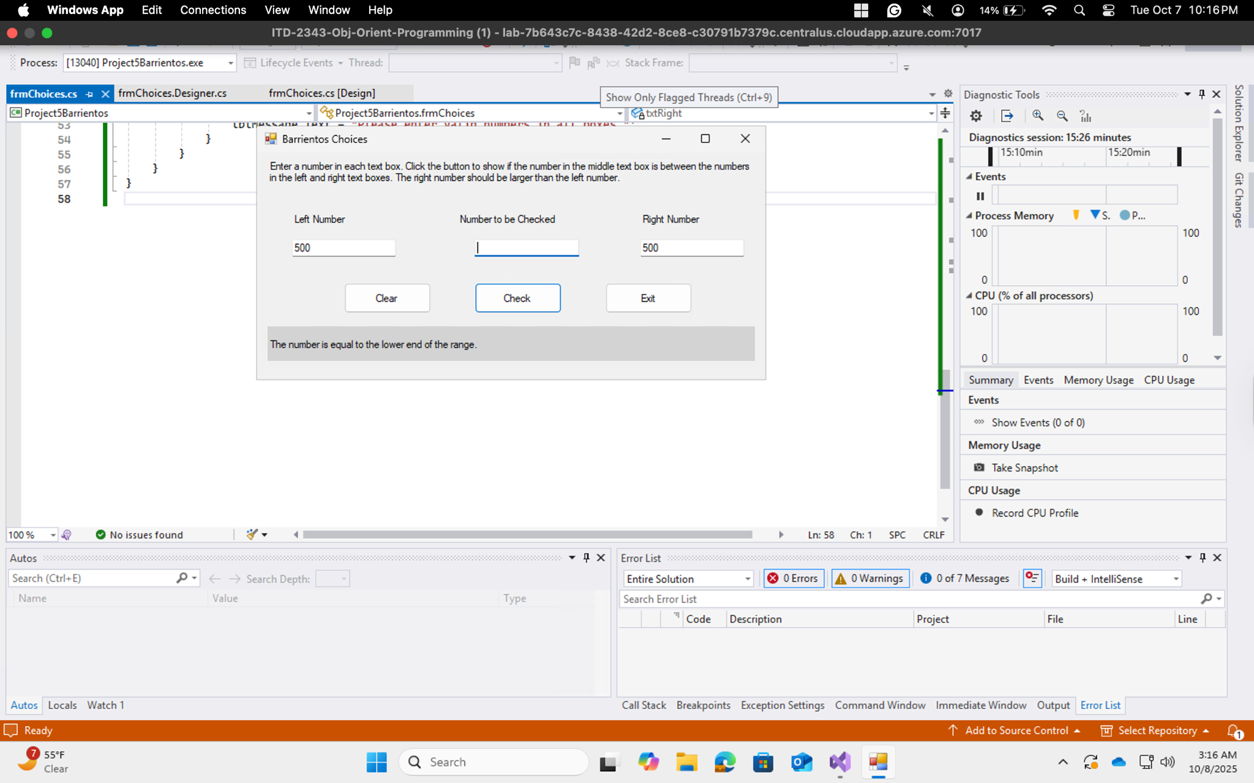

Test Scanerio 7: Clear Button

